

**National University of Computer and Emerging Sciences**

Database Systems

**Final Project Report of Online Voting System**

**STUDENTS NAME:** Usman Ali, Humaiz Tariq

**REGISTRATION NUMBERS:** 16i-0164,16i-0133

**DEGREE PROGRAM:** BS(CS)

**SEMESTER:** Summer 2019

**SUBJECT NAME:** Database Systems

**DATE OF SUBMISSION:** July 31, 2019

**SUBMITTED TO:**  Mr. Bilal Khalid Dar

**STUDENT SIGNATURES:**

__**____________________________________________________________**

**MARKS:**

__**____________________________________________________________**

**REMARKS:**

__**____________________________________________________________**

**TEACHERS SIGNATURE:**

__**____________________________________________________________**

**Table of contents:**

Project Description 3

Problem Statement 3

Problem Solution 3

Advantages/Benefits of the proposed system 3

Hardware/Software Requirements 4

Scope 5

Constraints 5

Roles and stakeholders 6

Work division 6

ERD 7

EERD 8

Logical schema (normalized) 9

Creating tables in SQL 9

Inserting data 11

**Project Description:**

Online voting system is a web-based voting system that will help to manage elections easily and securely. The system can help voters cast vote and will work for the general elections of a country. A database will maintain all the information of all the parties involved and more so a complete picture can be attained in reports generated from the DBMS. After registration and validation, this system will ensure that minimum human error occurs so that everything is safe and secure.

**Problem Statement:**

Traditional voting system is very inefficient in the sense that it is time consuming and requires a large human resource to conduct. There is no instant polling result and as a result, it is very hard to track who voted and who did not. The online voting system will be instant and it will be easy to keep track of voters with internet. A database will ensure that discrepancies do not arise and proper security is guaranteed to the voters.

**Problem Solution**:

Solve this issue by developing an online system providing availability to the voter to vote at the time they want and automatically gather the results without manipulation from different sources, as it will be an automated process. The web-based system will be connected to a database to ensure that all information is easily accessible, while ensuring its safety. This will also help in generating useful reports like voter vs non-voter count in individual constituency to help understand the issues preventing people from voting.

**Advantages/Benefits of the proposed system:**

1. Viewing the profile of the candidates

2. Voting availability throughout the day.

3. All people in a constituency who do not vote can be notified to vote

4. Greater accuracy than traditional system

5. Reliability,

a. through direct results after polling deadline

b. convenient for people not living in their constituency c. very reduced chance of manipulation in data

6. Validity of credentials can be checked with NADRA (existing database)

7. Automating the voting system to reduce human error

**Hardware/Software Requirements**

The system was developed on a system with the following specifications so it is assumed that any user accessing the system may need similar specification on their computer system.

Hardware Requirements:

* 1.8 GHz Intel Core i3 Processor
* 500GB Hard Drive
* 8GB RAM

Software Requirements:

* Windows Operating System (Windows 10 or higher)
* Oracle Developer
* XAMPP
* Web Browser such as Google Chrome and Firefox

Tools and Technologies:

The following tools were used in project development:

* MS Word
* MS Power Point
* Oracle Developer
* XAMPP
* GitHub Atom Text Editor
* Firefox Web Browser
* Windows 10

All documentation was done using MSWord. MS Power Point was used mainly for presentations. The backend was entirely constructed on Oracle Developer whereas the frontend required multiple applications. HTML and CSS forms and text handling was done mostly using Firefox Browser. XAMPP was used for PHP development and for connection with the SQL database coded in the Oracle Developer.

**Scope:**

**1.Voter:**

a. A voter will register in the system with essential information will be saved in the DBMS for validation

b. After validation, the voter can navigate through the interface to vote for the representative candidate and their party through their symbol and other identifying features. c. Once a vote is cast, the interface is locked and further votes cannot be cast and their casted vote cannot be changed later.

**2. Admin:**

a. Admin will manage voters and candidates, and can double check the information entered in the DBMS to ensure that reports can be generated to validate data

b. Admin will also manage the CONSTITUENCY to view the results and other reports such as number of voters, total number of registered voters, total population in the constituency etc.

**3. Candidate:**

a. Will make a profile that will have his basic information

b. Voters can view some of this information

c. Will have a symbol and a political party affiliation or lack thereof. d. Can see how many votes they have received

**4. Voting Procedure:**

a. Will have all information of the admin and the voters.

b. Will be used to generate important reports in the data

**Constraints:**

1. System is based on the Pakistani voting system.

2. Website will be on a local server and can only be accessed locally

3. System will run side by side to the traditional voting system to improve it easily.

**Roles and stakeholders:**

**Project Developers:**

Usman Ali - i160164

Humaiz Tariq - i160133

**Supervisors/Evaluators:**

Mr. Bilal Khalid

Mr. Usman Kaiser

**Work Division:**

**Documentation:**

100% Usman Ali

**Frontend:**

75% Humaiz

25% Usman

**Backend:**

75% Usman

25% Humaiz

**Parsing:**

50% both.

**ERD:**

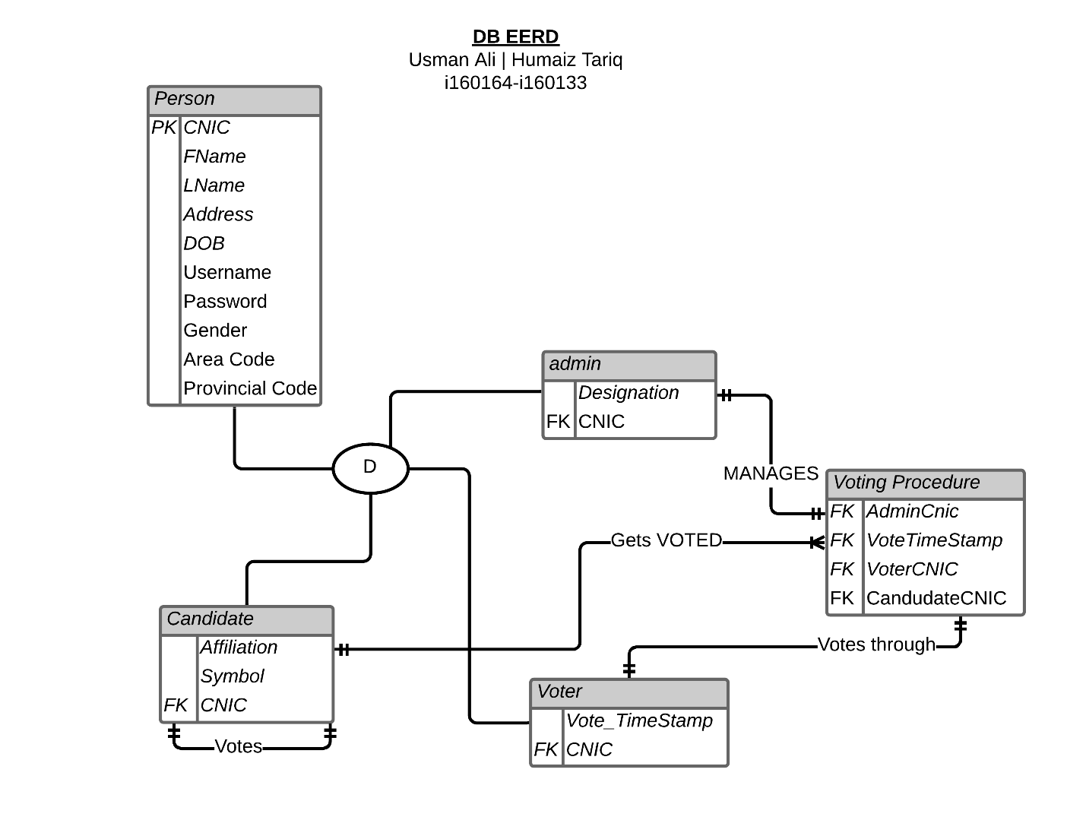

**EERD:**



**Logical Schema(Normalized):**

**Person:**

|  |  |  |  |  |  |  |  |  |  |
| --- | --- | --- | --- | --- | --- | --- | --- | --- | --- |
| CNIC | Fname | Lname | Address | DOB | Username | Pass | Gender | AreaCode | ProvincialCode |

**Admin:**

|  |  |
| --- | --- |
| Designation | Acnic |

**Candidate:**

|  |  |  |
| --- | --- | --- |
| Ccnic | Affiliation | Symbol |

**Voter:**

|  |  |
| --- | --- |
| Vcnic | VoteTimeStamp |

**Voting_procedure:**

|  |  |  |  |
| --- | --- | --- | --- |
| VoterCnic | VoteTimeStamp | AdminCnic | CandidateCnic |

**Creating tables in SQL:**

**Person table:**

CREATE TABLE person

(

cnic NUMBER (13) NOT NULL,

FName VARCHAR2(10),

LName VARCHAR2( 20 ),

Address VARCHAR2( 256 ),

DOB Date,

Username VARCHAR2(25),

Pass VARCHAR2(10),

Gender Char(1),

AreaCode VARCHAR2(4),

ProvincialCode VARCHAR2(4),

PRIMARY KEY(cnic)

);

**Admin table:**

CREATE TABLE admin

(

Designation VARCHAR2(30),

Acnic NUMBER(13) NOT NULL,

PRIMARY KEY(Acnic),

FOREIGN KEY (Acnic) REFERENCES person(cnic)

ON DELETE CASCADE

);

**Candidate table:**

CREATE TABLE candidate

(

Affiliation VARCHAR2(25),

Symbol VARCHAR2(10),

Ccnic NUMBER(13) NOT NULL,

PRIMARY KEY (Ccnic),

FOREIGN KEY (Ccnic) REFERENCES person(cnic)

ON DELETE CASCADE

);

**Voter table:**

CREATE TABLE voter

(

VoteTimeStamp DATE,

Vcnic NUMBER(13) NOT NULL,

PRIMARY KEY(Vcnic),

FOREIGN KEY (Vcnic) REFERENCES person(cnic)

ON DELETE CASCADE

);

**Voting_procedure table:**

CREATE TABLE voting_procedure

(

AdminCnic number(13),

VoteTimeStamp DATE,

VoterCnic NUMBER(13) NOT NULL,

PRIMARY KEY(VoterCnic),

FOREIGN KEY (VoterCnic) REFERENCES voter(Vcnic)

ON DELETE CASCADE,

FOREIGN KEY (Admincnic) REFERENCES admin(Acnic)

ON DELETE CASCADE

);

**Inserting data:**

**Insertions in person table:**

Insert into Person (cnic,Fname,Lname,Address,DOB,Username,Pass,Gender,AreaCode,ProvincialCode)values

(1340562312549,'Usman','Ali','H18-St5-I-8',TO_DATE('24/09/1965','dd/mm/yyyy'),'13405Usman','Ali549','M',2001,1001);

Insert into Person (cnic,Fname,Lname,Address,DOB,Username,Pass,Gender,AreaCode,ProvincialCode)values

(1340562896486,'Amna','Ali','H16-ST4-I-6',TO_DATE('22/08/1988','dd/mm/yyyy'),'13405Amna','Ali486','F',2001,1001);

Insert into Person (cnic,Fname,Lname,Address,DOB,Username,Pass,Gender,AreaCode,ProvincialCode)values

(1678909876549,'Haider','Khan','H-4-St1-G-11',TO_DATE('13/02/1087','dd/mm/yyyy'),'16789Haider','Khan549','M',2002,1001);

Insert into Person (cnic,Fname,Lname,Address,DOB,Username,Pass,Gender,AreaCode,ProvincialCode)values

(1312345678900,'Fatima','Naveed','H-18-St-12-H-8',TO_DATE('16/06/1978','dd/mm/yyyy'),'13123Fatima','Naveed900','F',2005,1002);

Insert into Person (cnic,Fname,Lname,Address,DOB,Username,Pass,Gender,AreaCode,ProvincialCode)values

(1898989898989,'Ali','Karam','H-89-St-9-D-17',TO_DATE('12/02/1990','dd/mm/yyyy'),'18989Ali','Karam989','M',2008,1003);

Insert into Person (cnic,Fname,Lname,Address,DOB,Username,Pass,Gender,AreaCode,ProvincialCode)values

(1897657890787,'Haris','Khalid','H-439-St-40-I-8',TO_DATE('20/02/1998','dd/mm/yyyy'),'18976Haris','Khalid787','M',2012,1004);

Insert into Person (cnic,Fname,Lname,Address,DOB,Username,Pass,Gender,AreaCode,ProvincialCode)values

(0976490875422,'Asma','Hassan','H-98-St-98-G-13',TO_DATE('01/02/1988','dd/mm/yyyy'),'09764Asma','Hassan422','F',2012,1004);

Insert into Person (cnic,Fname,Lname,Address,DOB,Username,Pass,Gender,AreaCode,ProvincialCode)values

(8798644378976,'Fateen','Bibi','H-98-St6-H-9',TO_DATE('05/09/1987','dd/mm/yyyy'),'87986Fateen','Bibi978','F',2006,1002);

Insert into Person (cnic,Fname,Lname,Address,DOB,Username,Pass,Gender,AreaCode,ProvincialCode)values

(1679732609457,'Aqib','Khan','H-9-St-9-I-9',TO_DATE('07/09/1989','dd/mm/yyyy'),'16797Aqib','Khan457','M',2008,1003);

Insert into Person (cnic,Fname,Lname,Address,DOB,Username,Pass,Gender,AreaCode,ProvincialCode)values

(6790753527697,'Fatir','Ullah','H-10-St-6-H-9',TO_DATE('16/10/1988','dd/mm/yyyy'),'67907Fatir','Ullah697','M',2007,1002);

Insert into Person (cnic,Fname,Lname,Address,DOB,Username,Pass,Gender,AreaCode,ProvincialCode)values

(7897532168900,'Rahima','Khan','H-5-St-5-G-11',TO_DATE('23/11/1967','dd/mm/yyyy'),'78975Rahima','Khan900','F',2009,1003);

Insert into Person (cnic,Fname,Lname,Address,DOB,Username,Pass,Gender,AreaCode,ProvincialCode)values

(7564668098754,'Mahnoor','Khan','H-6-St-1-H-12',TO_DATE('12/09/1978','dd/mm/yyyy'),'75646Mahnoor','Khan754','F',2010,1003);

Insert into Person (cnic,Fname,Lname,Address,DOB,Username,Pass,Gender,AreaCode,ProvincialCode)values

(1340562389769,'Ali','Hasnain','H-78-St-9-G15',TO_DATE('12/08/1989','dd/mm/yyyy'),'13405Ali','Hasnain769','M',2006,1002);

Insert into Person (cnic,Fname,Lname,Address,DOB,Username,Pass,Gender,AreaCode,ProvincialCode)values

(1789653467890,'Afifa','Alamdar','H-98-St-87-E-11',TO_DATE('14/07/1998','dd/mm/yyyy'),'17896Afifa','Alamdar890','F',2011,1004);

Insert into Person (cnic,Fname,Lname,Address,DOB,Username,Pass,Gender,AreaCode,ProvincialCode)values

(4297152311648,'Simra','Hope','H-345-St-12-I-8',TO_DATE('10/12/1991','dd/mm/yyyy'),'42971Simra','Hope648','F',2002,1001);

Insert into Person (cnic,Fname,Lname,Address,DOB,Username,Pass,Gender,AreaCode,ProvincialCode)values

(6110126487522,'Eileen','Hash','H-654-St-5-I-9',TO_DATE('30/11/1993','dd/mm/yyyy'),'61101Eileen','Hash522','F',2005,1002);

Insert into Person (cnic,Fname,Lname,Address,DOB,Username,Pass,Gender,AreaCode,ProvincialCode)values

(7840142156844,'Alex','Jonny','H-343-St-16-F-10',TO_DATE('28/09/1996','dd/mm/yyyy'),'78401Alex','Jonny844','F',2002,1001);

Insert into Person (cnic,Fname,Lname,Address,DOB,Username,Pass,Gender,AreaCode,ProvincialCode)values

(6850145413219,'Kevin','Oman','H-878-St-65-I-10',TO_DATE('16/04/1984','dd/mm/yyyy'),'68501Kevin','Oman219','M',2006,1002);

Insert into Person (cnic,Fname,Lname,Address,DOB,Username,Pass,Gender,AreaCode,ProvincialCode)values

(6115466842383,'Harris','Ham','H-105-St-95-I-8',TO_DATE('11/05/1956','dd/mm/yyyy'),'61154Harris','Ham383','M',2008,1003);

Insert into Person (cnic,Fname,Lname,Address,DOB,Username,Pass,Gender,AreaCode,ProvincialCode)values

(1268462364866,'Sam','Hardy','H-785-St-48-I-10',TO_DATE('09/06/1975','dd/mm/yyyy'),'12684Sam','Hardy866','F',2005,1002);

Insert into Person (cnic,Fname,Lname,Address,DOB,Username,Pass,Gender,AreaCode,ProvincialCode)values

(8461354894646,'Emma','Stone','H-282-St-3-H-8',TO_DATE('03/07/1998','dd/mm/yyyy'),'84613Emma','Stone646','F',2007,1002);

Insert into Person (cnic,Fname,Lname,Address,DOB,Username,Pass,Gender,AreaCode,ProvincialCode)values

(2486318453265,'Dave','Bon','H-276-St-75-G-7',TO_DATE('26/08/1984','dd/mm/yyyy'),'24863Dave','Bon265','M',2010,1003);

Insert into Person (cnic,Fname,Lname,Address,DOB,Username,Pass,Gender,AreaCode,ProvincialCode)values

(2156843568947,'John','James','H-723-St-37-G-6',TO_DATE('19/01/1994','dd/mm/yyyy'),'21568John','James947','M',2009,1003);

Insert into Person (cnic,Fname,Lname,Address,DOB,Username,Pass,Gender,AreaCode,ProvincialCode)values

(8795321323399,'Jim','Hopper','H-982-St-1-F-11',TO_DATE('15/06/1993','dd/mm/yyyy'),'87953Jim','Hopper399','M',2011,1004);

Insert into Person (cnic,Fname,Lname,Address,DOB,Username,Pass,Gender,AreaCode,ProvincialCode)values

(6110192866444,'Salehah','Arjumand','H-527-St-4-G-11',TO_DATE('10/02/1999','dd/mm/yyyy'),'61101Salehah','Arj444','F',2011,1004);

Insert into Person (cnic,Fname,Lname,Address,DOB,Username,Pass,Gender,AreaCode,ProvincialCode)values(1340628373229,'Hamid','Rao','H-6;St-98-H-9',TO_DATE('12/08.1987','dd/mm/yyyy'),'13406Hamid','Rao229','M',2011,1004);

Insert into Person (cnic,Fname,Lname,Address,DOB,Username,Pass,Gender,AreaCode,ProvincialCode)values

(3762537393006,'Fatima','Javed','H-9-St-6-F-7',TO_DATE('10/04/1978','dd/mm/yyyy'),'37625Fatima','Javed006','F',2010,1003);

Insert into Person (cnic,Fname,Lname,Address,DOB,Username,Pass,Gender,AreaCode,ProvincialCode)values

(8734764929200,'Iqra','Fatima','H-89-St-98-G-9',TO_DATE('12/09/1989','dd/mm/yyyy'),'87347Iqra','Fatima200','F',2009,1003);

Insert into Person (cnic,Fname,Lname,Address,DOB,Username,Pass,Gender,AreaCode,ProvincialCode)values

(1340562764336,'Aliza','Gul','H-7-St-09-D-17',TO_DATE('1/12/1999','dd/mm/yyyy'),'13405Aliza','Gul336','F',2002,1001);

Insert into Person (cnic,Fname,Lname,Address,DOB,Username,Pass,Gender,AreaCode,ProvincialCode)values

(1340561635371,'Kaleem','Ullah','H-89-St-5-E-9',TO_DATE('23/03/1980','dd/mm/yyyy'),'13405Kaleem','Ullah371','M',2001,1001);

Insert into Person (cnic,Fname,Lname,Address,DOB,Username,Pass,Gender,AreaCode,ProvincialCode)values

(0976544679949,'Fakhir','Khan','H-98-St-7-G-8',TO_DATE('22/04/1990','dd/mm/yyyy'),'09765Fakhir','Khan949','M',2003,1001);

Insert into Person (cnic,Fname,Lname,Address,DOB,Username,Pass,Gender,AreaCode,ProvincialCode)values

(9735356282117,'Rehan','Imran','H-09-St-5-D-9',TO_DATE('21/06/1989','dd/mm/yyyy'),'97353Rehan','Imran117','M',2005,1002);

Insert into Person (cnic,Fname,Lname,Address,DOB,Username,Pass,Gender,AreaCode,ProvincialCode)values

(9237636289999,'Imran','Ali','H-89-St-4-D-12',TO_DATE('24/03/1989','dd/mm/yyyy'),'92376Imran','Ali999','M',2006,1002);

**Insertions in admin table:**

insert into admin

values('a',4297152311648);

insert into admin

values('b',1340562312549);

insert into admin

values('c',1897657890787);

insert into admin

values('d',1789653467890);

insert into admin

values('e',1789653467890);

**Insertions in candidate table:**

insert into candidate

values('PPP','arrow',1678909876549);

insert into candidate

values('PML(N)','tiger',6790753527697);

insert into candidate

values('JUI','book',6115466842383);

insert into candidate

values('PTI','bat',8795321323399);

insert into candidate

values('JI','scale',7840142156844);

insert into candidate

values('PML(F)','rose',1340562764336);

insert into candidate

values('PML(Q)','cycle',9237636289999);

**Insertions in voter table:**

insert into voter

values('10-FEB-2019',1340562312549);

insert into voter

values('10-FEB-2019',1340562896486);

insert into voter

values('10-FEB-2019',1678909876549);

insert into voter

values('10-FEB-2019',1312345678900);

insert into voter

values('10-FEB-2019',1898989898989);

insert into voter

values('10-FEB-2019',1897657890787);

insert into voter

values('10-FEB-2019',8798644378976);

insert into voter

values('10-FEB-2019',1679732609457);

insert into voter

values('10-FEB-2019',6790753527697);

insert into voter

values('10-FEB-2019',7564668098754);

insert into voter

values('10-FEB-2019',6850145413219);

insert into voter

values('10-FEB-2019',1268462364866);

insert into voter

values('10-FEB-2019',2156843568947);

insert into voter

values('10-FEB-2019',6110192866444);

insert into voter

values('10-FEB-2019',6110126487522);

insert into voter

values('10-FEB-2019',3762537393006);

insert into voter

values('10-FEB-2019',9237636289999);

insert into voter

values('10-FEB-2019',1340562389769);

**Insertions in voting_procedure table:**

insert into voting_procedure

values(4297152311648,'10-FEB-2019',1340562312549);

insert into voting_procedure

values(1340562312549,'10-FEB-2019',1340562896486);

insert into voting_procedure

values(4297152311648,'10-FEB-2019',1678909876549);

insert into voting_procedure

values(1789653467890,'10-FEB-2019',1312345678900);

insert into voting_procedure

values(4297152311648,'10-FEB-2019',1898989898989);

insert into voting_procedure

values(1789653467890,'10-FEB-2019',1897657890787);

insert into voting_procedure

values(4297152311648,'10-FEB-2019',8798644378976);

insert into voting_procedure

values(1340562312549,'10-FEB-2019',1679732609457);

insert into voting_procedure

values(1789653467890,'10-FEB-2019',6790753527697);

insert into voting_procedure

values(4297152311648,'10-FEB-2019',7564668098754);

insert into voting_procedure

values(1789653467890,'10-FEB-2019',6850145413219);

insert into voting_procedure

values(1340562312549,'10-FEB-2019',1268462364866);

insert into voting_procedure

values(1789653467890,'10-FEB-2019',2156843568947);

insert into voting_procedure

values(1789653467890,'10-FEB-2019',6110192866444);

insert into voting_procedure

values(4297152311648,'10-FEB-2019',6110126487522);

insert into voting_procedure

values(1340562312549,'10-FEB-2019',3762537393006);

insert into voting_procedure

values(4297152311648,'10-FEB-2019',9237636289999);

insert into voting_procedure

values(1789653467890,'10-FEB-2019',1340562389769);